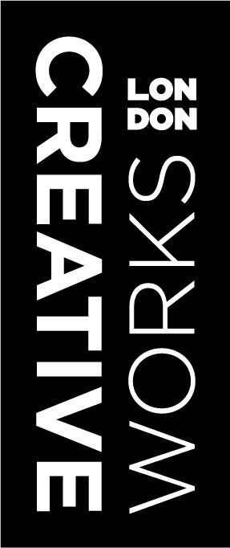
Creativeworks London
ROUND 7 APPLICATION deadlines
CREATIVE VOUCHER SCHEME
funded by THE ARTS AND HUMANITIES RESEARCH COUNCIL AND
EUROPEAN regional development fund

Wednesday 28th May 2014 | Creative Voucher Ideas Pool
Wednesday 25th June 2014 | Creative Voucher Application workshop
Wednesday 23rd July 2014 (5pm) | Deadline for applications
WB 4th August 2014 | Applications will be judged
By Friday 15th August 2014 | Successful applicants notified

