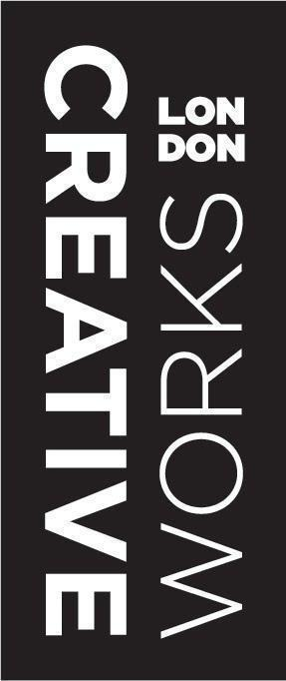

CREATIVEWORKS LONDON
FESTIVAL PROPOSAL FORM
FUNDED BY THE ARTS AND HUMANITIES RESEARCH COUNCIL

Please return completed forms to rachel@cwlondon.org.uk by
Friday 8th January 2016, 5pm.

CONTACT DETAILS:

SME Partner (if applicable)

Name:
Company name:
Email:
Contact number:
Website:
Twitter Handle:

Academic Partner (if applicable)

Name:
Academic institution:
Faculty:
Email:
Contact number:
Twitter Handle:

- Is this proposal jointly put forward by the SME and Academic partner (please tick as appropriate).

Yes
No

- Please give details if you are collaborating with an additional SME or Academic within the Creativeworks London community on this proposal.

- Please list the Creativeworks London funding scheme you were awarded i.e. Creative Voucher, Researcher-in-Residence, Creative Entrepreneur-in-Residence and BOOST scheme (list all that apply).

- Type of event (please tick as appropriate)

Talk
Panel Discussion
Performance
Exhibition / Installation
Workshop
Other (please state)

- Proposal title

- Proposal description (250 words max)

- Equipment Requirements (Please detail the equipment you will need, being as specific as possible)

Please note: We encourage you to bring your own equipment, including laptop, adapters, extension cables and so on. Tables and chairs are provided as standard. If there are items you are not able to provide, then Creativeworks London should be able to hire certain equipment from the venue, and will cover the cost of this. While we will do our best to provide everything you cannot bring yourselves, we may not be able to obtain everything.

Wi-Fi access required | Yes / No
Projector/Screen required | Yes / No
Microphones required | Yes / No
Speakers required | Yes / No
Number of power socket access
Maximum space requirement - only relevant for performance, exhibition, installation events (meters squared)
Any other requirements (please state)

- Space/Room set up (if appropriate). Please note that space/rooms at King’s College London will be allocated by the CWL team.

Boardroom
Theatre
Cabaret
Other (please state)

- Do you foresee any additional costs that may be incurred by your event, if yes please include brief written explanation of costs and breakdown if necessary. This should not include space hire, AV, catering costs etc. as these will already be covered by Creativeworks London. Please note that CWL may be able to put in a small amount of money towards your proposal, if however you need significant additional funding then please state where these funds will come from.

The Creativeworks London Festival will take place on Friday 29th April 2016 at King’s College London.

