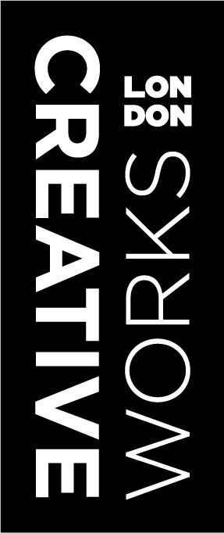
Creativeworks London
CREATIVE ENTrePRENEUR-IN-RESIDENCE
PROPOSAL FORM
funded by THE ARTS AND HUMANITIES RESEARCH COUNCIL

Before you apply, please ensure you have read the Creative Entrepreneur in Residence Guideline document. Please return completed submissions to Jodie@cwlondon.org.uk.

APPLICATION SECTION:

- Contact details

Name:
Company:
Position:
Postal address:
Email:
Website:
Contact number:

- Briefly describe the work of your practice (if freelance or a sole trader) or that of your company.
(100 words max)

- Proposal Title

- Proposal Description (200 words max)

- Academic partner

Name:
University: |  | Department:
Contact number:
Email:
Website:
Postal address:

- Please outline the nature of activities to be undertaken and the role that the institution will play in helping to support the residency (250 words max). This section should be completed with your partner academic.

- How will the residency assist your business goals or needs? (100 words max)

- How will the residency benefit the research partner? (100 words max)

- What potential might there be for the residency project contribute to London’s wider creative economy? (100 words max)

- Outline your project plan and time schedule. (150 words max)

- Budget: Income and Expenditure plus brief written justification of costs.

- IMPORTANT

Please remember to attach:

- Letter of support from the research institution.
- Biographies of Creative Entrepreneur and Research Partner.

Many thanks for applying for the Creative Entrepreneur in Residence scheme if you require any further information please visit www.creativeworkslondon.org.uk. To contact us email info@cwlondon.org.uk or call 020 7420 9436.

ADDITONAL COMPANY INFORMATION:

The information collected here allows us to determine if you are eligible for assistance and is not submitted as part of your application. If you are a freelancer or sole trader please complete the parts of the form indicated with an * and sign at the bottom.

Company information:

Company legal status:*
Business sector:*
Year established:*
Number of years trading:*
Company registration number:
Council company pay rates to:
Name(s) & titles(s) of Principal Director(s):

Employee numbers:

 | Full time | Part time
Number of male employees
Number of female employees

Equal opportunities information:

Owner/manager described as (please tick as appropriate): *

White British |  | Pakistani
White European |  | Bangladeshi
White (other background) |  | Caribbean
White and Black Caribbean |  | African
White and Black African |  | Any other Black background
White and Asian |  | Chinese
Any other Mixed Background |  | Any other
Indian
Is the organisation (please tick as appropriate):
Female led
Disabled led
Black minority ethnic-led
None of the above

Owner/manager age * (please tick as appropriate):
16 - 24
25 - 49
50 - 64
66 +

Verification of information:

Have you applied to Creativeworks London before?*
If yes, please give details:*

I confirm that the information provided in this form is accurate and that I have read understood and received the additional “funding application guidelines” document.
Signed |  | Print name
Position |  | Date

Data protection: I give my consent for this information to be made available to public bodies and independent auditors who may be required to review this data for funding compliance and output verification purposes. Information supplied on this form may be held on computer and passed to other departments and project partners, which may contact you with details of other services in which you may be interested.

